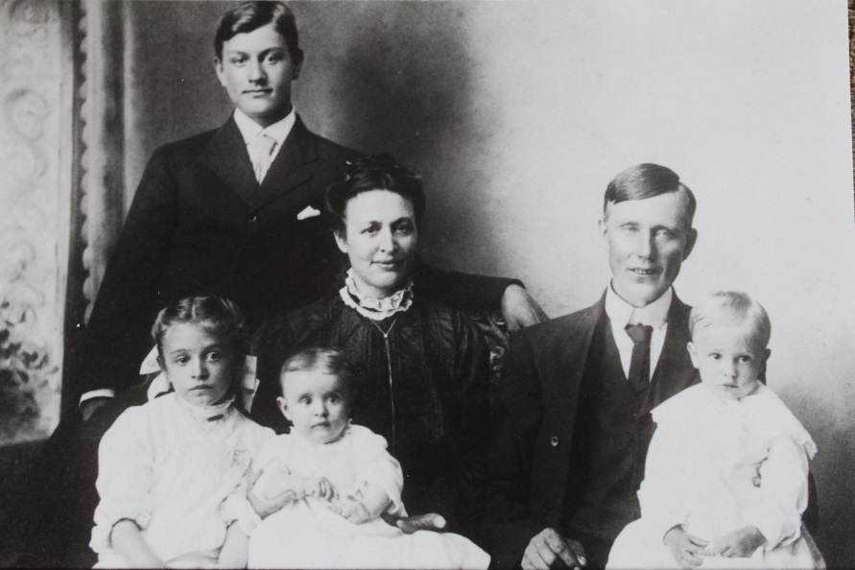

(l-r) Philip (standing), Emma, Wilma, Maggie Kern, John Adam, and Luther List – 1909 (est.)

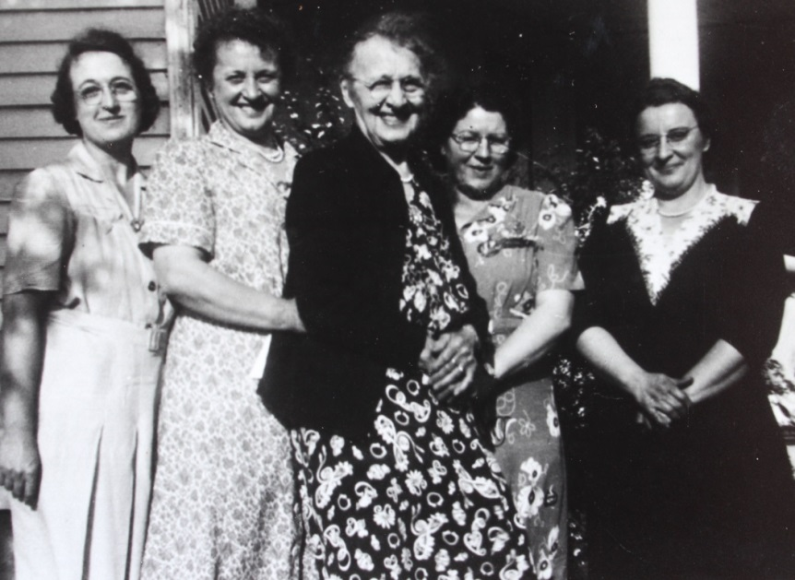

(l-r) Mabel List, wife of Noah List; Emma List, Luther List oldest sister;

Margaret Kerns List; Dorothy E. Wolfe List; Wilma List, Luther’s youngest sister